1.Linear Search
Code:
import java.util.*;
public class lin {
public static void main(String[] args) {
Scanner s=new Scanner(System.in);
System.out.print("N:");
int n=s.nextInt();
int [] arr=new int[n];
System.out.print("Array elements:");
for(int i=0;i<n;i++){
arr[i]=s.nextInt();
}
System.out.print("Search element:");
int x=s.nextInt();
for(int i=0;i<n;i++){
if(arr[i]==x){
System.out.print("Element found at position "+i);
return;
}
}
System.out.print(-1);
}
}
Output:
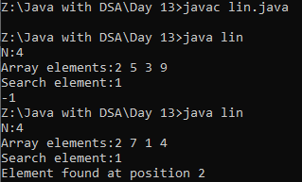
2.Binary Search
Code:
import java.util.*;
class binary{
public static void main (String[] args) {
Scanner sc=new Scanner(System.in);
System.out.print("N: ");
int n=sc.nextInt();
System.out.print("Enter an array: ");
int[] arr=new int[n];
for(int i=0;i<n;i++){
arr[i]=sc.nextInt();
}
System.out.print("Search Element: ");
int target=sc.nextInt();
int low=0;
int high=arr.length-1;
while(low<=high){
int mid=(low+high)/2;
if(arr[mid]==target){
System.out.print("Element found at the index: "+mid);
return;
}
else if(arr[mid]>target){
high=mid-1;
}
else{
low=mid+1;
}
}
System.out.print("Element not found.....");
}
}
Output:

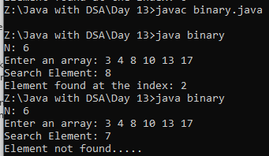
3.Insert element at position using binary search
Code:
import java.util.*;
class pos{
public static void main (String[] args) {
Scanner sc=new Scanner(System.in);
System.out.print("N: ");
int n=sc.nextInt();
System.out.print("Enter an array: ");
int[] arr=new int[n];
for(int i=0;i<n;i++){
arr[i]=sc.nextInt();
}
System.out.print("Search Element: ");
int target=sc.nextInt();
int low=0;
int high=arr.length-1;
while(low<=high){
int mid=(low+high)/2;
if(arr[mid]==target){
System.out.print("Element found at the position:"+mid);
return;
}
else if(arr[mid]>target){
high=mid-1;
}
else{
low=mid+1;
}
}
System.out.print("Element insert at the position:"+low);
}
}
Output:
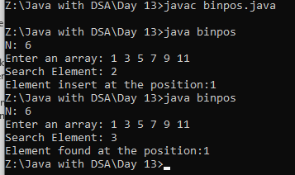
4.Find the peek element of an array using binary search
Code:
import java.util.*;
public class Main {
public static void main(String[] args) {
Scanner s=new Scanner(System.in);
System.out.print("N:");
int n=s.nextInt();
int [] arr=new int[n];
System.out.print("Array elements:");
for(int i=0;i<n;i++){
arr[i]=s.nextInt();
}
int f=0;
int l=n-1;
while(f<=l){
int mid=(f+l)/2;
if(arr[mid]>arr[mid-1] && arr[mid]>arr[mid+1]){
System.out.print(arr[mid]);
return;
}
else if(arr[mid]>arr[mid-1] && arr[mid]<arr[mid+1]){
f=mid+1;
}
else{
l=mid-1;
}
}
System.out.print(-1);
}
}
Output:
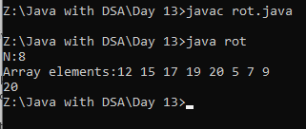
5.Bubble Sort
Code:
import java.util.*;
public class Main {
public static void main(String[] args) {
Scanner s=new Scanner(System.in);
System.out.print("N:");
int n=s.nextInt();
int [] arr=new int[n];
System.out.print("Array elements:");
for(int i=0;i<n;i++){
arr[i]=s.nextInt();
}
for(int i=0;i<n-1;i++){
for(int j=0;j<n-1-i;j++){
if(arr[j]>arr[j+1]){
int temp=arr[j];
arr[j]=arr[j+1];
arr[j+1]=temp;
}
}
}
for(int i=0;i<n;i++){
System.out.print(arr[i] +" ");
}
}
}
Output:
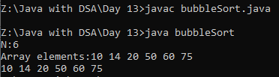
6.Selection sort
Code:
import java.util.*;
public class Selection {
public static void main(String[] args) {
Scanner s=new Scanner(System.in);
System.out.print("N:");
int n=s.nextInt();
int [] arr=new int[n];
System.out.print("Array elements:");
for(int i=0;i<n;i++){
arr[i]=s.nextInt();
}
for(int i=0;i<n-1;i++){
int min=i;
for(int j=i+1;j<n;j++){
if(arr[j]<arr[min]){
min=j;
}
}
int temp=arr[min];
arr[min]=arr[i];
arr[i]=temp;
}
for(int i=0;i<n;i++){
System.out.print(arr[i] +" ");
}
}
}
Output:
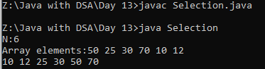

7.Insertion sort
Code:
import java.util.*;
public class insert{
public static void main(String[] args) {
Scanner sc=new Scanner(System.in);
System.out.print("N:");
int n=sc.nextInt();
int [] arr=new int[n];
System.out.println("Array Elements:");
for(int i=0;i<n;i++){
arr[i]=sc.nextInt();
}
for(int i=1;i<n;i++){
int key=arr[i];
int j=i-1;
while(j>=0 && arr[j]>key){
arr[j+1]=arr[j];
j--;
}
arr[j+1]=key;
}
System.out.print("Sorted array:");
for(int x:arr){
System.out.print(x + " ");
}
}
}
Output:
